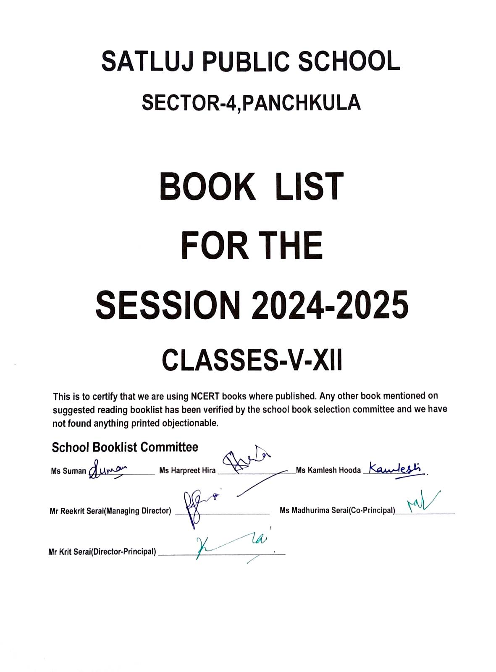
CLASS V(2024-25)
MENDATORY/NCERT BOOKS
SUBJECT | NAME OF THE BOOK
ENGLISH | MARIGOLD-NCERT
MATHEMATICS | MATH MAGIC-NCERT
HINDI | RIMJHIM-NCERT
EVS | LOOKING AROUND-NCERT

*SUGGESTED OPTIONAL BOOKS FOR CO-SCHOLASTIC/ADDITIONAL ACADEMICS
ENGLISH | GRAMMAR GEAR-CAMBRIDGE PUB
HINDI | HINDI VYAKARAN-VIVA EDUCATION
PUNJABI | RABAAB-PUNJABI PAATH PUSTAK(2)-S.P. PUB  RABAAB-PUNJABI VYAKARAN ATE RACHNAVALI(3)-S.P. PUB
ARTS | COLOURS AND CRAFT-VIVA EDUCATION  PLAIN ART FILE (A4 SIZE),OIL PASTELS-1 SET,PENCIL COLOURS-1 SET
VALUE EDUCATION | VALUE EDUCATION-VIVA EDUCATION
INFORMATION TECHNOLOGY | IT PLANET-CODE BOTICS-PMP PUB
FRENCH | IDEES(DEBUTANT)-FULL MARKS
GENERALKNOWLEDGE | GK ACHIEVERS-PMP PUB
EVS | GREEN LEAVES-EVERGREEN PUB

STATIONERY AND NOTEBOOKS
REGISTERS-12(SIZE 28L*22B)
FOLDER-1

CLASS VI(2024-25)
MENDATORY/NCERT BOOKS
SUBJECT | NAME OF THE BOOK
ENGLISH | HONEY SUCKLE-NCERT  A PACT WITH THE SUN-NCERT
MATHEMATICS | MATHEMATICS-NCERT
SCIENCE | SCIENCE –NCERT
SOCIAL SCIENCE | SOCIAL AND POLITICAL LIFE-1-NCERT  OUR PAST-1-NCERT  THE EARTH OUR HABITAT-NCERT
HINDI | VASANT-1-NCERT  BAAL RAMKATHA-NCERT
SANSKRIT | RUCHIRA-1-NCERT

*SUGGESTED OPTIONAL BOOKS FOR CO-SCHOLASTIC/ADDITIONAL ACADEMICS
ENGLISH | GRAMMAR GEAR-CAMBRIDGE PUB
MATHEMATICS | MATHEMATICS LAB ACTIVITY BOOK-PRACHI
SCIENCE | SCIENCE LAB MANUAL-PRACHI
SOCIAL SCIENCE | MAP PRACTICE BOOK-FULL MARKS
HINDI | HINDI VYAKARAN-VIVA EDUCATION
SANSKRIT | SANSKRIT VYAKARAN-VIVA EDUCATION
PUNJABI | RABAAB-PUNJABI PAATH PUSTAK(6)-S.P. PUB  RABAAB-PUNJABI VYAKARAN ATE RACHNAVALI(6)-S.P. PUB
ARTS | COLOURS AND CRAFT-VIVA EDUCATION  1 PLAIN ART FILE –A3,OIL PASTELS-1 SET,PENCIL COLOURS-1 SET
VALUE EDUCATION | VALUE EDUCATION-VIVA EDUCATION
INFORMATION TECHNOLOGY | IT PLANET-CODE BOTICS-PMP PUB
FRENCH | IDEES(0)-FULL MARKS
GENERAL KNOWLEDGE | GK ACHIEVERS-PMP PUB

STATIONERY AND NOTEBOOKS
REGISTERS-12(SIZE 28L*22B)
FOLDER-1

CLASS VII(2024-25)
MENDATORY/NCERT BOOKS
SUBJECT | NAME OF THE BOOK
ENGLISH | HONEYCOMB-NCERT  ALIEN HAND-NCERT
MATHEMATICS | MATHEMATICS-NCERT
SCIENCE | SCIENCE –NCERT
SOCIAL SCIENCE | OUR ENVIRONMENT-NCERT  SOCIAL AND POLITICAL LIFE-NCERT  OUR PAST-II-NCERT
HINDI | VASANT-2-NCERT  BAAL MAHABHARAT-NCERT
SANSKRIT | RUCHIRA-2-NCERT

*SUGGESTED OPTIONAL BOOKS FOR CO-SCHOLASTIC/ADDITIONAL ACADEMICS
ENGLISH | GRAMMAR GEAR-CAMBRIDGE PUB
MATHEMATICS | MATHEMATICS LAB ACTIVITY BOOK-PRACHI
SCIENCE | SCIENCE LAB MANUAL-PRACHI
SOCIAL SCIENCE | MAP PRACTICE BOOK-FULL MARKS
HINDI | HINDI VYAKARAN-VIVA EDUCATION
SANSKRIT | SANSKRIT VYAKARAN-VIVA EDUCATION
PUNJABI | RABAAB-PUNJABI PAATH PUSTAK(7)-S.P. PUB  RABAAB-PUNJABI VYAKARAN ATE RACHNAVALI(7)-S.P. PUB
ARTS | GO CREATIVE-EVERGREEN PUB  1 PLAIN ART FILE –A3 ,WATER COLOURS(24 COLOUR SET),  ROUND PAINTING BRUSH(NUMBER-0,2,4,6),PENCIL COLOURS-1 SET
VALUE EDUCATION | VALUE EDUCATION-VIVA EDUCATION
INFORMATION TECHNOLOGY | IT PLANET-CODE BOTICS-PMP PUB
FRENCH | IDEES(1)-FULL MARKS
GENERAL KNOWLEDGE | GK ACHIEVERS-PMP PUB

STATIONERY AND NOTEBOOKS
REGISTERS-12(SIZE 28L*22B)
FOLDER-1

CLASS VIII(2024-25)
MENDATORY/NCERT BOOKS
SUBJECT | NAME OF THE BOOK
ENGLISH | HONEYDEW-NCERT  IT SO HAPPENED-NCERT
MATHEMATICS | MATHEMATICS-NCERT
SCIENCE | SCIENCE –NCERT
SOCIAL SCIENCE | RESOURCES AND DEVELOPMENT-NCERT  SOCIAL AND POLITICAL LIFE-3-NCERT  OUR PAST-III-NCERT
HINDI | VASANT-3-NCERT  BHARAT KI KHOJ-NCERT
SANSKRIT | RUCHIRA-3-NCERT

*SUGGESTED OPTIONAL BOOKS FOR CO-SCHOLASTIC/ADDITIONAL ACADEMICS
ENGLISH | GRAMMAR GEAR-CAMBRIDGE PUB
MATHEMATICS | MATHEMATICS LAB ACTIVITY BOOK-PRACHI
SCIENCE | SCIENCE LAB MANUAL-PRACHI
SOCIAL SCIENCE | MAP PRACTICE BOOK-FULL MARKS
HINDI | HINDI VYAKARAN-VIVA EDUCATION
SANSKRIT | SANSKRIT VYAKARAN-VIVA EDUCATION
PUNJABI | RABAAB-PUNJABI PAATH PUSTAK(8)-S.P. PUB  RABAAB-PUNJABI VYAKARAN ATE RACHNAVALI(8)-S.P. PUB
ARTS | GO CREATIVE-EVERGREEN PUB  1 PLAIN ART FILE –A3 ,WATER COLOURS(24 COLOUR SET),  ROUND PAINTING BRUSH(NUMBER-0,2,4,6),PENCIL COLOURS-1 SET
VALUE EDUCATION | VALUE EDUCATION-VIVA EDUCATION
INFORMATION TECHNOLOGY | IT PLANET-CODE BOTICS-PMP PUB & TEACHERS NOTES
FRENCH | IDEES(2)-FULL MARKS
GENERAL KNOWLEDGE | GK ACHIEVERS-PMP PUB

STATIONERY AND NOTEBOOKS
REGISTERS-12(SIZE 28L*22B)
FOLDER-1

CLASS IX(2024-25)
MENDATORY/NCERT BOOKS
SUBJECT | NAME OF THE BOOK
ENGLISH | BEEHIVE-NCERT  MOMENTS-NCERT  WORDS AND EXPRESSIONS-(1)-NCERT
MATHEMATICS | MATHEMATICS-NCERT
SCIENCE | SCIENCE –NCERT
SOCIAL SCIENCE | INDIA AND CONTEMPORARY WORLD-1-NCERT  ECONOMICS-NCERT  DEM. POL.-NCERT  CONT. INDIA-NCERT
HINDI | SPARSH-1-NCERT  SANCHAYAN-1-NCERT
PUNJABI | PUNJABI SAHIT MALA-NCERT  PUNAJBI VANGI-NCERT

*SUGGESTED OPTIONAL BOOKS FOR CO-SCHOLASTIC/ADDITIONAL ACADEMICS
MATHEMATICS | ACTIVITY PLUS IN MATHEMATICS-FULL MARKS  REFERENCE BOOK-MATHEMATICS-FULL MARKS
SCIENCE | PRACTICAL SKILLS IN SCIENCE-FULL MARKS
HINDI | HINDI VYAKARAN-PRACHI PUB
PUNJABI | PUNJABI VYAKARAN ATE RACHNAVALI-S.P. PUB
ARTS | ART PLUS-OPTIMA (G.RAM BOOKS)  1 PLAIN ART FILE-A4 SIZE(SPIRAL 50 PAGES), ARTISTIC WATER COLOURS (CAKES), PAINTING BRUSH NO.-1,3,5, SKETCH PENS-1 SET, PENCIL COLOURS-1 SET
VALUE EDUCATION | VALUES-LIFE SKILLS AND ATTITUDES-EVERGREEN PUB
INFORMATION TECHNOLOGY | UNIQUE INFORMATION TECHNOLOGY(CODE-402) UNIQUE PUB  UNIQUE INFORMATION TECHNOLOGY-LAB MANUAL-UNIQUE PUB
PHYSICAL EDUCATION | PHYSICAL EDUCATION LAB MANUAL-E-5 PUBLISHERS

STATIONERY AND NOTEBOOKS
REGISTERS-12(SIZE 28L*22B)
FOLDER-1

CLASS X(2024-25)
MENDATORY/NCERT BOOKS
SUBJECT | NAME OF THE BOOK
ENGLISH | FOOTPRINT WITHOUT FEET-NCERT  FIRST FLIGHT-NCERT  WORDS AND EXPRESSIONS-(2)-NCERT
MATHEMATICS | MATHEMATICS-NCERT  MATHEMATICS EXEMPLER-NCERT
SCIENCE | SCIENCE –NCERT  NCERT EXEMPLER-NCERT
SOCIAL SCIENCE | INDIA AND CONTEMPORARY WORLD-II-NCERT  UNDERSTANDING ECO. DEVELOPMENT-NCERT  DEM. POL.-II-NCERT  CONT. INDIA-NCERT
HINDI | SPARSH-II-NCERT  SANCHAYAN-II-NCERT
PUNJABI | PUNJABI SAHIT MALA-NCERT  PUNAJBI VANGI-NCERT
*SUGGESTED OPTIONAL BOOKS FOR CO-SCHOLASTIC/ADDITIONAL ACADEMICS
ENGLISH | BBC-BBC
MATHEMATICS | ACTIVITY PLUS IN MATHEMATICS-FULL MARKS  REFERENCE BOOK-MATHEMATICS-FULL MARKS
SCIENCE | PRACTICAL SKILLS IN SCIENCE-FULL MARKS
HINDI | HINDI VYAKARAN-PRACHI PUB
PUNJABI | PUNJABI VYAKARAN ATE RACHNAVALI-S.P. PUB(9&10)
ARTS | ART PLUS-OPTIMA (G.RAM BOOKS)  1 PLAIN ART FILE-A4 SIZE(SPIRAL 50 PAGES), ARTISTIC WATER COLOURS (CAKES), PAINTING BRUSH NO.-1,3,5, SKETCH PENS-1 SET, PENCIL COLOURS-1 SET
INFORMATION TECHNOLOGY | UNIQUE INFORMATION TECHNOLOGY(CODE-402) UNIQUE PUB  UNIQUE INFORMATION TECHNOLOGY-LAB MANUAL-UNIQUE PUB
PHYSICAL EDUCATION | PHYSICAL EDUCATION LAB MANUAL-E-5 PUBLISHERS

STATIONERY AND NOTEBOOKS
REGISTERS-12(SIZE 28L*22B)
FOLDER -1

CLASS XI(2024-25)
MENDATORY/NCERT BOOKS
SUBJECT | NAME OF THE BOOK
ENGLISH | HORNBILL-NCERT  SNAP SHOTS-NCERT
MATHEMATICS | MATHEMATICS TEXT-NCERT
PHYSICS | PHYSICS TEXTBOOK-(PART 1 &2)-NCERT
CHEMISTRY | CHEMISTRY(PART 1 & 2)-NCERT
BIOLOGY | BIOLOGY TEXTBOOK-NCERT
ECONOMICS | MICRO ECONOMICS-NCERT  STATISTICS-NCERT
BUSINESS STUDIES | BUSINESS STUDIES TEXTBOOK-NCERT
ACCOUNTS | ACCOUNTANCY-FINANCIAL ACCOUNTING(PART1 &2)-NCERT
SOCIOLOGY | SOCIOLOGY(PART1 & 2) – NCERT
POLITICAL SCIENCE | POLITICAL THEORY-NCERT
FINE ARTS | AN INTRODUCTION TO INDIAN ART-PART-1-NCERT
HOME SCIENCE | HUMAN ECOLOGY AND FAMILY SCIENCES-(PART1&2)NCERT
*SUGGESTED OPTIONAL BOOKS FOR CO-SCHOLASTIC/ADDITIONAL ACADEMICS
ENGLISH | BBC-BBC
MATHEMATICS | MATHEMATICS-(PART 1 &2)-FULL MARKS  EXAMPLER ACTIVITIES IN MATHEMATICS-FULL MARKS
ACCOUNTS | REFERENCE BOOK-JUNEJA &CHAWLA-KALYANI PUB
PHYSICS | PHYSICS LAB MANUAL-EVERGREEN PUB
CHEMISTRY | CHEMISTRY LAB MANUAL-EVERGREEN PUB
ECONOMICS | REFERENCE BOOK-T.R. JAIN-V.K. GLOBAL PUB
BIOLOGY | BIOLOGY LAB MANUAL-EVERGREEN PUB
INFORMATION TECHNOLOGY | UNIQUE INFORMATION TECHNOLOGY(CODE-802) UNIQUE PUB
PHYSICAL EDUCATION | PHYSICAL EDUCATION PRACTICAL BOOK-S.P. PUB  TEXTBOOK OF PHYSICAL EDUCATION-S.P. PUB
HOME SIENCE | HUMAN ECOLOGY AND FAMILY SCIENCES-PREMIER PUB
FINE ARTS | 1 PLAIN SKETCH FILE-A2 SIZE, SHADING PENCILS
MUSIC | SANGEET VISHARAD-HATHRASA & TEACHERS NOTES
MARKETING | TEACHERS NOTES
FOOD NUTRITION & DIETETICS | TEACHERS NOTES
MASS MEDIA STUDIES | TEACHERS NOTES

STATIONERY AND NOTEBOOKS
REGISTERS-12(SIZE 28L*22B)
FOLDER-1

CLASS XII(2024-25)
MENDATORY/NCERT BOOKS
SUBJECT | NAME OF THE BOOK
ENGLISH | FLAMINGO-NCERT  VISTAS-NCERT
MATHEMATICS | MATHEMATICS (PART 1 &2)-NCERT
PHYSICS | PHYSICS TEXTBOOK-(PART 1 &2)-NCERT
CHEMISTRY | CHEMISTRY(PART 1 & 2)-NCERT
BIOLOGY | BIOLOGY TEXTBOOK-NCERT
ECONOMICS | INDIAN ECONOMIC DEVELOPMENT-NCERT  MACRO ECONOMICS-NCERT
BUSINESS STUDIES | BUSINESS STUDIES TEXTBOOK(PART 1&2)-NCERT
ACCOUNTS | ACCOUNTS-NCERT
SOCIOLOGY | SOCIOLOGY(PART- A & B) – NCERT
POLITICAL SCIENCE | CONT. WORLD POLITICS-NCERT  POLITICS IN INDIA SINCE INDEPENDENCE-NCERT
FINE ARTS | AN INTRODUCTION TO INDIAN ART-PART-2-NCERT
HOME SCIENCE | HUMAN ECOLOGY AND FAMILY SCIENCES-(PART1&2)NCERT
*SUGGESTED OPTIONAL BOOKS FOR CO-SCHOLASTIC/ADDITIONAL ACADEMICS
ENGLISH | BBC-BBC
MATHEMATICS | MATHEMATICS-(PART 1 &2)-FULL MARKS  EXAMPLER ACTIVITIES IN MATHEMATICS-FULL MARKS
ACCOUNTS | REFERENCE BOOK-T. S. GREWAL- SULTAN CHAND
PHYSICS | PHYSICS LAB MANUAL-EVERGREEN PUB
CHEMISTRY | CHEMISTRY LAB MANUAL-EVERGREEN PUB
ECONOMICS | REFERENCE BOOK-T.R. JAIN-V.K. GLOBAL PUB
BIOLOGY | BIOLOGY LAB MANUAL-EVERGREEN PUB
INFORMATION TECHNOLOGY | UNIQUE INFORMATION TECHNOLOGY(CODE-802) UNIQUE PUB
PHYSICAL EDUCATION | PHYSICAL EDUCATION PRACTICAL BOOK-S.P. PUB  TEXTBOOK OF PHYSICAL EDUCATION-S.P. PUB
HOME SIENCE | HUMAN ECOLOGY AND FAMILY SCIENCES-PREMIER PUB
FINE ARTS | 1 PLAIN SKETCH FILE-A2 SIZE, WATER COLOURS (ARTIST)
MUSIC | SANGEET VISHARAD-HATHRASA & TEACHERS NOTES
MARKETING | TEACHERS NOTES
FOOD NUTRITION & DIETETICS | TEACHERS NOTES
MASS MEDIA STUDIES | TEACHERS NOTES

STATIONERY AND NOTEBOOKS
REGISTERS-12(SIZE 28L*22B)
FOLDER-1

